Contents

Introduction 2

Screen View – 1 - CSV 2

Wireframe 2

Business LOGIC note:

When in doubt, All work should be astehecially pleasing and user friendly. Any questions save until the end and a manager can assist. Please review with manager any highligheted notes

# Introduction

This work task is to debug/modify “[Download Sample Format For Bulk Upload](javascript:__doPostBack('ctl00$ContentPlaceHolder1$lnkDownload',''))”. Do not change any other functionality already existing. Refer to picture for task#

http://73.165.171.37/JGPTestNew/Sr_App/EditUser.aspx

## Screen View – 1 - CSV

### Wireframe

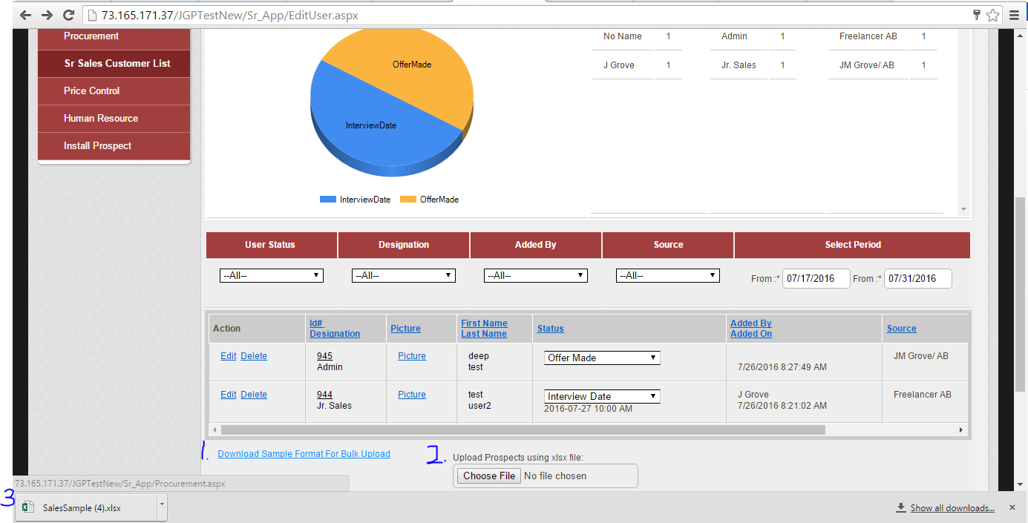

1. Update “[Download Sample Format For Bulk Upload](javascript:__doPostBack('ctl00$ContentPlaceHolder1$lnkDownload',''))” see xls template CSV example:
2. Check for duplicate phone # & email. If no duplicate exists: a pop up opens “all entries were uploaded successfully”
   1. If duplicate exists, all other XLS entries will be entered into the DB and a pop up opens:
3. “Email or phone number already exists for the following records, Do you want to update the existing record?:”

List “Lname” & “primary contact phone #” of ALL duplicate entries in pop up

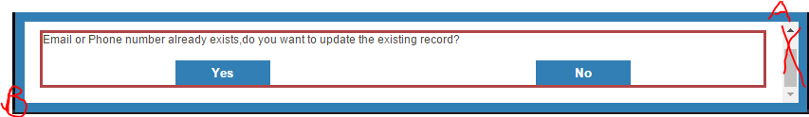

* 1. Remove scroll bar
  2. Format pop up border & buttons to black & red (exactly like existing formatting!)
     1. If “no” is selected, duplicate entries will be unchanged and return to screen
     2. If “yes” is selected, any fields that differ between existing & XLS will be overwritten by XLS
        1. ONLY fields that are overwritten, will be an entry into employee profile page touch point LOG as an entry

Ex.